Name:___________________________________________________________________________ Period:_______________

APUSH | Unit One “1491-1607”
Directions: For each reading section of Unit 1, define the important vocabulary words and answer the reading questions that follow using specific details. It is imperative that you complete your readings thoughtfully and independently. Students who do not do their reading will not do well in this course.
UNIT 1.1 | Contextualizing Period 1
Key term/event | Definition (Who, What, When, Where…) | Significance (Why this term matters)
Contextualization
Objective | Key Developments
Explain the context for  European encounters in the  Americas from 1491 to 1607. | - What was the turning point in world history for exploration in America?  - Why did the existing cultures vary when Columbus got to the Americas?  - Summarize some of the reasons for exploration.  Contact between Europeans and the natives of America touched off a transatlantic trade in _________________, _________________, and _____________________ known as the Columbian Exchange.  - What were some of the original crops in America? What was caused by the Europeans coming to America?  - How did enslaved Africans add to the diversity of people in America?
Timeline of Events in Unit 1
Please copy timeline from 1.1. Dots are major dates you will see at the end of the section.

1450
1500
1550
1600
1650

UNIT 1.2 | Native American Societies Before European Contact
Key term/event | Definition (Who, What, When, Where…) | Significance (Why this term matters)
Land bridge
Mayans
Aztecs
Incas
Corn (maize)
longhouses
Iroquois Confederation
Woodland Mound Builders
Objective | Key Developments
Explain how and why various native populations in the period before European contact interacted with the natural environment in North America. | Migrants from Asia might have crossed a ________________________ that once connected __________ & _______________.  The population of the Americas was probably between _____ million and ____ million people.  Cultures of Central and South America  Mayas Aztecs Incas  They were a civilization between ______ to _____. Where were the Mayans located? Modern day location:___________ Aztec Capital:_________________ Modern day location:____________  What were some of the similarities between all three civilizations:  Cultures of North America  - General Patterns  - Why were native societies in the north less complex than the central and southern regions?  - What did the men mostly do?  - What did the women mostly do?  - Language Differences  - What’s the major difference between Indo-European languages and American Indian languages?  - The largest were the ___________________ in the northeast, _______________ on the Great Plains, and ________________ in the southwest.  - Southwest Settlements  - _______________, _______________, and ____________ were the main American Indian groups.  - Where were most of these civilizations living?  - ______________ allowed economic growth and development of irrigation systems.  - Northwest Settlements  - In modern day Alaska & northern California, people lived in _____________________.  - Most of their stories, legends, and myths were carved in _____________________..  - Great Basin and Great Plains  - These people were mobile because their food moved. What were some of the animals they hunted?  - Mississippi River Valley  - What are the Adena-Hopewell culture most famous for?  - Northeast Settlements  - Which descendents came to the New York area?  - Multiple families related to their ______________ lineage and lived in ______________.  - Many of the tribes formed a powerful political union called the _____________________________  - Atlantics Seaboard Settlements  - Where were these settlements mostly located and who were many of them descended from?
UNIT 1.3 | European Exploration in the Americas
Key term/event | Definition (Who, What, When, Where…) | Significance (Why this term matters)
gunpowder
Sailing compass
Printing press
Isabella and Ferdinand
Christopher Columbus
Protestant Reformation
Henry the Navigator
Nation-states
Treaty of Tordesillas
Objective | Key Developments
Explain the causes of exploration and conquest of the New World by various European nations. | The European Context for Exploration  Who was “technically” the first people to visit Greenland and North America?  CHANGES IN THOUGHT AND TECHNOLOGY  - During what period in Europe allowed inventions to be created or improved upon?  - What were the different inventions created or improved upon?  - How did these inventions lead to exploration and conquest in the New World? (Provide example and explanations)  RELIGIOUS CONFLICT  - Catholic Victory in Spain  - In the 8th century, _______________ invaders known as the Moors conquered much of Spain.  - _______________________ reconquered much of the land and set up several independent kingdoms.  - In 1492, Isabella and Ferdinand funded __________________________’s first voyage across the Atlantic.  What did the unification of Isabella and Ferdinand signal?  - Protestant Revolt in Northern Europe  - Christians in Germany, England, France, Holland, and other places were agree with the ____________ church and the ______________.  - They created a new sect of Christianity called ______________________.  - What type of competition did this lead to between the Catholics and the Protestants?  Why was this competition between Catholics and Protestants a motivating factor in exploration and conquest of the New World?  EXPANDING TRADE  European kingdoms had competition to increase trade with __________, __________, and ___________.  How did European merchants originally get to Asia to trade? Why was this not liked by Europeans?  What event in 1453 made it impossible to trade with Asia?  - New Routes  - What appeared to be the two ways Europeans could get to Asia?  - Henry the Navigator Importance:  - Slave Trading  - Why did the Portuguese start trading for enslaved people in West Africa?  - Why is this significant when talking about the colonies in America?  How can expanding trade be a motivating factor in the exploration and conquest of the New World?  DEVELOPING NATION-STATES  What were most of these small kingdoms and empires starting to transform into?  What was needed to justify monarchs’ right to rule?  DIVIDING THE AMERICAS  Identify the different claims in America came from and if there were any disputes in the claims.  Spanish and Portuguese Claims English Claims French Claims  Explorer(s) Christopher Columbus John Cabot Giovanni da Verrazzano  Claims & Disputes
UNIT 1.4 | Columbian Exchange, Spanish Exploration, and Conquest
Key term/event | Definition (Who, What, When, Where…) | Significance (Why this term matters)
Smallpox & measles
capitalism
Joint-stock company
Objective | Key Developments
Explain causes of the Columbian Exchange and its effect on Europe and the Americas during the period after 1492.  . | CHRISTOPHER COLUMBUS  - Plans to Reach Asia  - Christopher Columbus was famous for reaching the Bahamas, but he found little amounts of ________________.  - Did he reach China and India? Circle YES or NO  THE COLUMBIAN EXCHANGE  What exactly is the Columbian Exchange?  For the diagram below, please illustrate the goods, animals, and germs.  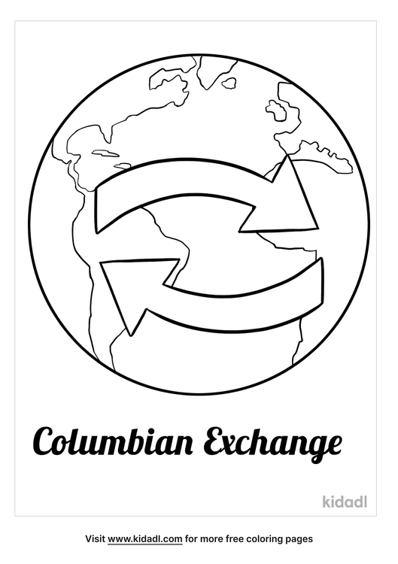  There were many diseases brought to the Native Americans, but what new disease was contracted by the Europeans:____________________________.  What effect did the Columbian Exchange have on the population in Europe, Africa, and Asia?  What effect did the Columbian Exchange have on the population in America?  THE RISE OF CAPITALISM  ___________________________ and ________________________ to new resources encouraged trade which led to economic, political, and social changes.  Political Effects Economic Effects Social Changes
UNIT 1.5 | Labor, Slavery, and Caste in the Spanish Colonial System
Key term/event | Definition (Who, What, When, Where…) | Significance (Why this term matters)
Conquistadores
Hernan Cortes
Francisco Pizarro
Encomienda system
Asiento System
Transatlantic Slave Trade
Middle Passage
Objective | Key Developments
Explain how the growth of the Spanish Empire in North America shaped the development of social and economic structures  over time | SPANISH EXPLORATION AND CONQUEST  Who were the two conquistadores that set the stage for Spain to have initial supremacy in the Americas?  - ________________________ with the Aztecs in Mexico  - ________________________ with the Incas in Peru  - ________________________ & ____________________ was sent back to Spain, which made the country extremely rich  - Indian Labor  - What system did the Spanish use to control the indigenous people of America?  - How did this system work out in the end? (Youtube Heimler’s “APUSH 1.6” video)  - Enslaved African Labor  - Where did the Portuguese originally have African slaves?  - What caused the Spaniards add African slaves to their labor force in the Americas?  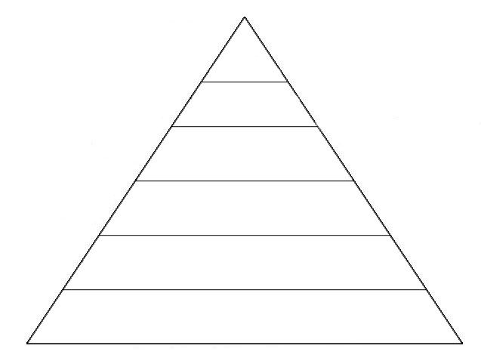  - The ___________________ system allowed the Spanish king to tax colonists for each enslaved person they imported to the Americas.  - African Resistance  - In which ways did Africans resist or rebel?  SPANISH CASTE SYSTEM  Why did the Spanish government develop a caste system in the Spanish colonies?  Label the hierarchy of this system in the diagram to the right.
UNIT 1.6 | Cultural Interactions in the Americas
Key term/event | Definition (Who, What, When, Where…) | Significance (Why this term matters)
Bartolomé de Las Casas
New Laws of 1542
Juan Gines de Sepulveda
Objective | Key Developments
Explain how and why European and Native  American perspectives of others developed and changed in the period. | Describe some of the conflicting worldviews of the Europeans and Native Americans.  - Religious Views  - Roles of Women  - Land Use  EUROPEAN TREATMENT OF NATIVE AMERICANS  - Spanish Policy  - Bartolomé de Las Casas Viewpoint on treatment/enslavement of Indians  - Juan Gines de Sepulveda’s viewpoint on treatment/enslavement of Indians  - Result of Valladolid Debate  - English Policy  - What were the initial interactions with Indians?  - What were the interactions like after conflict and warfare become more prevalent?  - French Policy  - What were the views of Native Americans like for the French?  - What were the French looking for economically?  - What did the French build in the Great Lakes Regions?  SURVIVAL STRATEGIES BY NATIVE AMERICANS  How did Native American groups respond to trying to protect their cultures? (Please provide examples of each way as well)  THE ROLE OF AFRICANS IN AMERICA  How did Africans contribute to being a third culture in the Americas?  How did Europeans rationalize using African slavery as justified?

